Spotify Songs Recommendations using Machine Learning

J.Tirumala (211FA04579) G.M Sudheshna(211FA04610)

Department of CSE Department of CSE

Vignan University, Vadlamudi Vignan University, Vadlamudi

Guntur, Andhra Pradesh Guntur, Andhra Pradesh

[tirumala4579@gmail.com](mailto:tirumala4579@gmail.com) [garresudheshna03@gmail.com](mailto:garresudheshna03@gmail.com)

G. Keerthi Yamini(221LA04003) Syed.Zadeer(221LA04011) Department of CSE Department of CSE

Vignan University, Vadlamudi Vignan University, Vadlamudi

Guntur, Andhra Pradesh Guntur, Andhra Pradesh [goginenikeerthi30@gmail.com](mailto:goginenikeerthi30@gmail.com) [zadeer4011@gmail.com](mailto:zadeer4011@gmail.com)

Under The Estimated Guideline Of A Target Report Submitted To:

M. Bhargavi Mam Assistant Professor

Dept of CSE Vignan University Vadlamudi, Guntur, Andhra Pradesh, India - 522213

# Introduction:

In today's digital age, music streaming platforms like Spotify have revolutionized the way people discover and consume music. With millions of songs available at their fingertips, users often face the challenge of finding new music that aligns with their preferences and tastes. To address this challenge, the development of personalized recommendation systems has become paramount.

The aim of this project is to design and implement a personalized song recommendation system leveraging machine learning techniques, tailored specifically for Spotify users. By analyzing user listening patterns, song attributes, and other relevant data, the system will generate personalized song recommendations that cater to each user's unique musical preferences.

# Abstract:

In today's digital era, music streaming platforms like Spotify offer users access to vast libraries of music, presenting an overwhelming array of choices for listeners. The challenge lies in facilitating personalized music discovery experiences tailored to individual tastes and preferences. This capstone project aims to develop a sophisticated song recommendation system using machine learning techniques, specifically designed for Spotify users. By leveraging user listening history, song attributes, and other relevant data, the system will generate personalized song recommendations to enhance user engagement and satisfaction.

# Existing Problem:

## Abundance of Choices:

* Music streaming platforms offer extensive catalogs of songs, leading to overwhelming choices for users.
* Users may find it challenging to navigate through vast libraries and discover new music that aligns with their preferences.

## Generic Recommendations:

* Existing recommendation systems often provide generic suggestions that may not reflect the nuanced tastes of individual users.
* Users may receive recommendations that do not resonate with their unique preferences and listening habits.

## Limitations of Collaborative Filtering:

* Collaborative filtering methods, commonly used in recommendation systems, may overlook important contextual factors and user-specific attributes.
* These methods might not accurately capture evolving user preferences and behaviors over time.

## Challenges with Content-based Filtering:

* Content-based filtering approaches rely heavily on song metadata and lack the ability to capture complex user preferences and contextual information.
* They may not effectively adapt to changing user tastes and evolving music trends.

## Stagnant Recommendation Lists:

* Existing recommendation systems may suffer from stagnant recommendation lists that fail to evolve with users' changing preferences.
* Users may encounter repetitive recommendations or outdated suggestions, leading to decreased user engagement and satisfaction.

## Dynamic Nature of Music Preferences:

* Music preferences are dynamic and subject to change over time.
* Existing recommendation systems may struggle to adapt to evolving user behaviors and preferences, resulting in suboptimal recommendations.

## User Satisfaction and Engagement:

* Suboptimal recommendations can lead to reduced user satisfaction and engagement with the platform.
* Users may become disenchanted with the music discovery experience, leading to decreased usage and retention rates.

Addressing these challenges requires the development of personalized recommendation systems that can effectively analyze user interactions, understand individual preferences, and adapt to evolving tastes. By leveraging advanced machine learning algorithms and innovative data modeling techniques, there is an opportunity to enhance the music discovery experience for users and foster greater engagement with music streaming platforms like Spotify.

# Proposed Work:

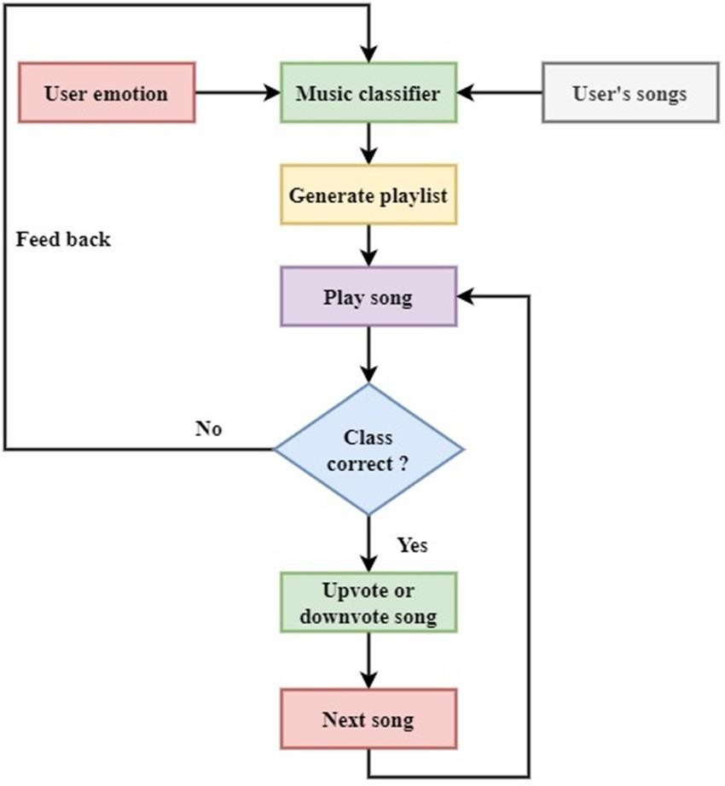

**Literature Survey**

Submitted by:

Batch-19

Reg.no:

211FA04579

211FA04610

221LA04003

221LA04011

|  |  |  |  |  |  |  |  |  |
| --- | --- | --- | --- | --- | --- | --- | --- | --- |
| Sl.no | Title | Journal/Conference | Year | Authors | Approach | Objective | Result | Limitations |
| 1 | A Smart Spotify Assistance and Recommendation  System | Conference | 2023 | Keshav Allawadi, Charvi Vij | Personalized Recommendation System, Content-based Recommendation System, Hybrid Recommendation System, Spotify Library, Spotify Assistant, Spotify Web API | The objective of the project is to develop a dynamic recommendation system for Spotify users, enabling them to discover new songs based on their preferences and search history. | The result of the project is a personalized music recommendation system with accuracy depending on the effectiveness of the correlation between user behavior and song characteristics. | Dependency on User Behavior, Limited Dataset Availability, Algorithmic Bias and Fairness, Scalability Challenges, Privacy and Data Protection Concerns, Subjectivity in Recommendations |
| 2 | Spotify Genre Recommendation Based On User Emotion Using Deep Learning | Conference | 2022 | Shanthakumari R, Nalini C, Vinothkumar S, Venkata Prasanna R, Nikilesh A, Nitin Pranav S M | Scholarly Research, Conference Organization | The objective of the project is to organize and host the Fifth International Conference on Computational Intelligence and Communication Technologies (CCICT), providing a platform for researchers to present findings, discuss trends, and foster collaboration in these domains. Its aim is to advance knowledge, innovation, and practical applications in computational intelligence and communication technologies through scholarly exchange and networking opportunities. | It seeks to enhance understanding, develop practical solutions, and foster collaboration within the CCICT domain. The anticipated outcome includes advancements in knowledge, impactful contributions to the field, and strengthened networks among researchers and practitioners. | While the project endeavors to push boundaries in computational intelligence and communication technologies, limitations may arise in terms of resource constraints, technical feasibility, and unforeseen complexities within the research domain. Additionally, the applicability of findings in real-world scenarios and the scalability of proposed solutions might pose challenges that require careful consideration and further investigation. |
| 3 | A Machine Learning Approach Prediction of Spotify Music Popularity by Audio Features | conference | 2022 | Joshua S. Gulmatico, Aimee Acoba, Julie Ann B. Susa, Marte D. Nipas, Mon Arjay F. Malbog, Jennalyn N. Mindoro | Machine learning algorithms (MLA), Data Analysis, Spotify data, audio feature | The objective of this research is to investigate the relationship between audio features extracted from Spotify music and song popularity measured by the number of streams. The study aims to develop prediction models using machine learning algorithms to classify songs based on their popularity. | The study presents the development of prediction models using four machine learning algorithms: Linear Regression, Random Forest Classifier, and K-means Clustering. The models were evaluated based on their accuracy in predicting hit songs. Linear Regression yielded a training mean of 0.1254 and a testing mean of 0.136, while the Random Forest Model achieved a 95.37% accuracy rate. | One limitation of the study is that the prediction accuracy of the models may vary depending on the quality and quantity of the data used for training. Additionally, the study acknowledges the potential for improvement by incorporating more metadata about the artist and track to enhance accuracy and outcomes in future research. |
| 4 | Music Recommendation Based on Artist Novelty and Similarity | Journal | 2014 | Ning Lin, Ping-Chia Tsai, Yu-An Chen, Homer H. Chen | The paper proposes a music recommendation system that focuses on promoting new talents and providing users with novel music experiences. Unlike traditional systems that recommend songs based on popularity, this system considers both artist similarity and artist novelty. It first identifies candidate artists similar to the user's favorite artists and then selects those with higher novelty scores. The system then generates a playlist composed of the most popular songs of the selected artists. | The primary goal is to address the drawbacks of traditional recommendation systems by recommending new and novel music to users. The system aims to provide users with refreshing and fortuitous music experiences while promoting emerging talents in the music industry. | The proposed system achieves high novelty scores and competitive user-preference scores compared to the popular recommender system, Spotify Radio. Experimental results show that the system recommends songs with higher novelty, introducing users to new artists and songs they haven't heard before. | 1. The system's performance is evaluated using a small pool of subjects recruited from a university campus, which may not represent the diversity of music preferences among all users.  2. The novelty score is based on the popularity of artists and songs, which may not accurately reflect users' preferences for new and undiscovered music.  3. The system relies on artist similarity and popularity information obtained from external sources such as Last.fm and Google, which may not always be up-to-date or accurate.  4. The evaluation does not consider long-term user satisfaction or the impact of repeated exposure to new artists and songs over time. |
| 5. | SentiSpotMusic: a music recommendation system based on sentiment analysis | Conference | 2021 | Eva Sarin, Megha, Srishti Vashishtha, Simran Kaur | The authors propose a music recommendation system, SentiSpotMusic, based on sentiment analysis using Tableau Dashboard and Spotify dataset. They conduct exploratory data analysis and sentiment analysis to reveal insights into music consumption patterns and sentiment trends. | The objective is to develop an accurate and efficient recommendation system that considers user sentiments to provide personalized music recommendations. | The results include insights such as the impact of song attributes (e.g., energy, danceability) on popularity, commonalities among popular songs, and sentiment trends in personalized Spotify playlists. | The limitations of the study include the need for further refinement and validation of the recommendation system, as well as potential challenges in accurately capturing user sentiments from music data. |
| 6 | Music Mood Prediction Based on Spotify’s Audio Features Using Logistic Regression | Conference | 2022 | Marvin Ray Dalida, Lyah Bianca Aquino, William Cris Hod, Rachelle Ann Agapor, Shekinah Lor Huyo-a, Gabriel Avelino Sampedro | The authors propose an innovative approach for modeling a track’s mood based on audio components extracted from the Spotify application program interface (API). They use logistic regression for mood prediction and evaluate the model's performance using stratified k-fold cross-validation and confusion matrix analysis. | The primary objective is to predict a song's mood based on 12 features extracted from the Spotify audio components. The study aims to identify the factors that significantly affect a track's mood based on its audio features. | - Logistic regression model achieved an average accuracy of 0.9645, precision of 0.8601, recall of 0.8581, and f1 score of 0.8583.  - Significant factors affecting mood prediction were identified as energy, acousticness, valence, instrumentalness, and speechiness.  - Minor factors affecting mood prediction were identified as time signature, key, and tempo. | - The study focuses solely on audio features extracted from Spotify's API and does not consider other factors such as lyrics or user preferences.  - The dataset may not fully represent the diversity of music genres and may not generalize well to all types of music.  - Future research could explore incorporating lyrics data or user listening history to improve mood prediction accuracy. |
| 7 | Tuning in to Personalized Music: A Spotify API-Based Hybrid Recommendation System Integrating Content-Based and Popularity-Based Approaches | Journal | 2023 | - Tarush Bachal (MIT World Peace University, Pune, Maharashtra)  - Dr. Vitthal S. Gutte (MIT World Peace University, Pune, Maharashtra)  - Ashwin Kumar (MIT World Peace University, Pune, Maharashtra)  - Anish Bachal (MIT World Peace University, Pune, Maharashtra) | The paper presents a comprehensive approach for constructing a music recommendation system that integrates both content-based and popularity-based approaches using the Spotify API. The content-based algorithm analyzes audio features to personalize song recommendations, while the hybrid model combines user preferences with trending music to provide a balanced recommendation list. Additionally, a user-friendly GUI implemented using Tkinter allows users to interact with the system, input their favorite music, and receive personalized recommendations instantly. | The objective of the study is to improve music discovery for users in the era of expansive music libraries and personalized user experiences by developing a robust recommendation system using the Spotify API. | - The recommendation system demonstrated remarkable accuracy, precision, and user satisfaction.  - Content-based recommendations based on audio features such as danceability, energy, and valence proved to be intuitive and aligned with users' musical tastes.  - The incorporation of popularity-based recommendations through a hybrid model significantly enhanced the quality of suggestions | The paper does not explicitly mention any limitations of the proposed recommendation system or areas for improvement. However, future research directions are discussed in the "Future Scope" section, suggesting potential areas for further enhancement and refinement of the recommendation system. |
| 8 | Song Recommendation System based on Mood Detection using Spotify’s Web API | conference | 2022 | Anusha Bhowmick, Kankshini Shamkuwar, Dr. J D Dorathi Jayaseeli, Dr. D Malathi | Content-based recommendation system utilizing Spotify's Web API for song features retrieval, combined with emotion detection using facial expressions. | To develop a recommendation system that considers both a user's music listening history and their current emotional state to provide personalized song recommendations. | The system successfully generates a 20-song playlist based on the user's Spotify listening history and the current emotion detected, achieving an accuracy of approximately 67% in emotion recognition. | The study acknowledges the scope for improving the accuracy of emotion recognition. Additionally, while the system provides recommendations based on user history and current emotion, there may still be limitations in accurately capturing user preferences and emotional states. |
| 9 | Music Recommendation System Using Real-Time Parameters | Conference | 2023 | - Shivam Dawar  - Mohammed Fardin Hossain  - Soumitra Chatterjee  - Dr. Malarvizhi S | The proposed system utilizes real-time parameters such as time, location, weather, facial expressions, artists, and audio attributes to accurately determine the user’s emotional state. It comprises three primary components: mood detection, user song profile creation, and recommender system integration. Mood detection involves using facial recognition algorithms, while the user song profile is built using APIs like Spotify and LastFM. | To create a music recommendation system that provides personalized recommendations based on real-time parameters, enhancing the user's music listening experience. | - Utilized a 5-layer CNN model for facial emotion detection with an overall accuracy of 90%.  - Developed a deep learning model to classify user song profiles with an average accuracy of 96.23%.  - Implemented a recommender system that integrates mood detection and user profile data, achieving an average accuracy of 95.69% in recommending songs. | - The system's performance heavily relies on the accuracy of facial emotion detection, which may vary based on factors like lighting conditions and camera quality.  - Dependency on APIs like Spotify and LastFM for gathering user music preferences may limit the system's scalability and real-time data availability.  - Limited discussion on the scalability and generalizability of the proposed system beyond the specific datasets and scenarios mentioned in the study. |
| 10 | A Song Classifier for Predicting User Preference Based on Spotify Song Attributes | Confernce | 2023 | Yong Yang Boon, Hui Yun Chia, Siew Mooi Lim, Annebel Yun Ying Choong | Several algorithms are evaluated, including Random Forest Classifier, Logistic Regression, Gaussian Naive Bayes, Extreme Gradient Boosting, Dummy Classifier, and Stacking Classifier. | The objective is to develop a song classifier that predicts whether a user likes or dislikes a song based on its attributes, contributing to the improvement of music recommendation systems on platforms like Spotify. | The Stacking Classifier model is chosen as the best model due to its consistently high accuracy, precision, recall, and F1 score. The deployment process involves utilizing the Spotify API to retrieve song attributes, encoding them, and inputting them into the model for prediction. The model's accuracy is evaluated using two different playlists, with predicted results of songs that the user would like or dislike. | While the study achieves promising results, there are some limitations. The model's performance heavily relies on the quality and relevance of the features extracted from the Spotify Song Attributes dataset. Additionally, the study does not explore user demographic data, which could further improve the model's accuracy in predicting user preferences. Furthermore, the deployment process might require users to obtain song or playlist IDs, which could be inconvenient for some users. Further research could address these limitations to enhance the model's effectiveness and user experience. |